

Server and Client System Configuration in Sentosa Hospital with Windows 11 and 7

Group 2:

|  |  |
| --- | --- |
| Abdur Rashid Firdaus | (2320010109) |
| Ahmad Maulana Ibrahim | (2320010111) |
| Ayunda Pramita Kurnia Hapsari | (2320010189) |

Faculty:

Ivan Firdaus, S.T

Class:

2CS1

CEP CCIT FACULTY OF ENGINEERING UNIVERSITY OF INDONESIA

2024

|  |
| --- |
| **PROJECT INFORMATION** |

|  |
| --- |
| Project Title : Server and Client System Configuration in Sentosa Hospital with Windows 11 and 7  Batch Code : 2CS1  Start Date : June 15, 2024  End Date : June 30, 2024  Name of Faculty : Ivan Firdaus, S.T  Names of Developers:   1. Abdur Rashid Firdaus 2. Ahmad Maulana Ibrahim 3. Ayunda Pramita Kurnia Hapsari   Date of Submission: June 30, 2024 |

|  |
| --- |
|  |

|  |
| --- |
| **CERTIFICATE OF ORIGINALITY**  This is to certify that the project report titled " Server and Client System Configuration in Sentosa Hospital with Windows 11 and 7" is an original work completed by Abdur Rashid Firdaus, Ahmad Maulana Ibrahim, and Ayunda Pramita Kurnia Hapsari. This project has been submitted in partial fulfillment of their course requirement at the National Institute of Information Technology (NIIT).  The project report has been prepared under our research and experiment, and it is ensured that the work presented in this report is the result of the individual efforts of the aforementioned students. The contents of this report have not been submitted to any other institution or organization for the award of any degree, diploma, or other similar recognition.  Authors acknowledge that the ideas, designs, and implementations presented in this project report are the intellectual properties of the students mentioned above. Any use or reproduction of this work must give proper credit to the original authors.  Authors hereby endorse the authenticity and originality of the work presented in this project report and confirm that it meets the academic standards and requirements set forth by the National Institute of Information Technology (NIIT).  Coordinator:  Mr Ivan Firdaus, S.T |

|  |
| --- |
| Author would like to acknowledge the completion of the insightful paper titled " Server and Client System Configuration in Sentosa Hospital with Windows 11 and 7." This paper comprehensively discusses how to configure DNS and FTP in the Linux software.  The contents of this paper provide a detailed overview of how to configure various service using windows server. The paper serves as a way of understanding windows server as a subject for this second semester.  Depok, 30 June 2024  Authors |

|  |
| --- |
| For the system in this project, authors create a server using the Windows 11 operating system. Then, for the client we use Windows 7. The services that are configured in this project include ADDS, DNS, Organization Unit, User, Folder Management, GPO, & Web Server. The benefit that we can get in this project is that we can configure the server manager in the Windows operating system. Not only that, we can also create our own DNS, OU, User, Folder Management, GPO, & Web Server. |

|  |
| --- |
| **SERVICES** |

|  |
| --- |
| 1. **Active Directory Domain Service (AD DS)**   A directory service provided by Microsoft for Windows domain networks. It is included in most Windows Server operating systems as a set of processes and services. AD DS stores information about members of the domain, including devices and users, verifies their credentials, and defines their access rights.   1. **DNS (Domain Name System)**   A hierarchical and decentralized naming system for computers, services, or other resources connected to the Internet or a private network. It translates human-friendly domain names to the numerical IP addresses needed for locating and identifying computer services and devices.   1. **Organization Unit (OU)**   A subdivision within an Active Directory into which you can place users, groups, computers, and other organizational units. It provides a way to create a logical, hierarchical grouping of objects within the domain, which can then be managed and configured independently.   1. **Users**   Refers to individuals who have access to the network and its resources. In Active Directory, user accounts are created to authenticate and authorize users to access resources.   1. **GPO (Group Policy Object)**   A collection of settings that define what a system will look like and how it will behave for a defined group of users. GPOs are used in Active Directory to enforce policies and settings across multiple computers and users in an organization.   1. **Management Folder**   Typically refers to a directory or location within a network where management scripts, tools, and other administrative resources are stored and managed. This folder is used by IT administrators to organize and access management-related files easily. |

|  |
| --- |
| **SERVICES** |

|  |
| --- |
| 1. **Web Server**   Web server is a computer that stores web server software and a website's component files. A web server connects to the Internet and supports physical data interchange with other devices connected to the web. |

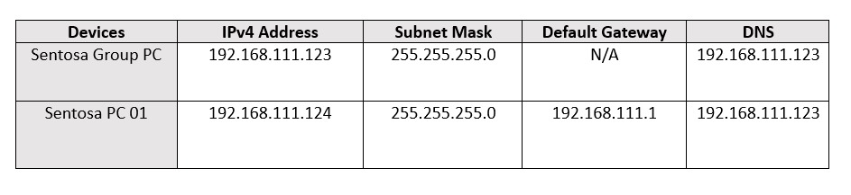

Operating system virtual machine specification :

1. Windows Server 2022

* 2GB RAM
* 50GB Storages
* 1 CPU
* 1 Internal Network Adapters

1. Windows 7 Ultimate Client

* 2GB RAM
* 32GB Storages
* 1 CPU
* 1 Internal Network Adapters

|  |
| --- |
|  |

|  |
| --- |
| **CONFIGURATION** |

1. C**HANGE COMPUTER NAME & IP ADDRESS**

Open the server manager, then open "Local server". This time we will change the computer name & IP address. To change the computer name, press the computer name section. Then, press "Change". After that, enter the computer name you want. In this project, we will use the computer name "Sentosa Group". Then save the settings. Once finished, your windows will restart automatically. If successful, when you go to the server manager, your computer name will change.

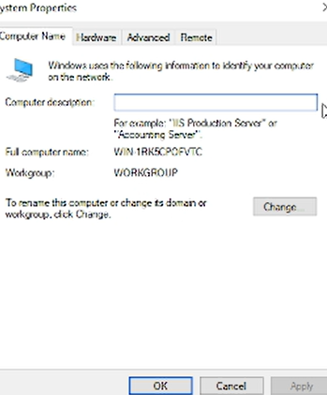 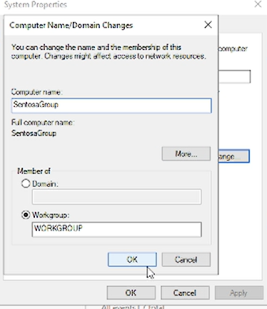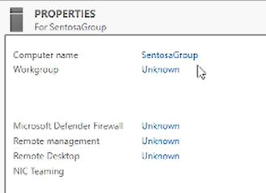

To change the IP address, you can go to the local server again. Then you can press the Ethernet section. Select an existing network then press "Properties", after that you can click on the IPV4 section and click “Properties”. Enter the IP address you want to use. In this project, we use the IP address 192.168.111.123 for the server. Click OK and the IP address will change.

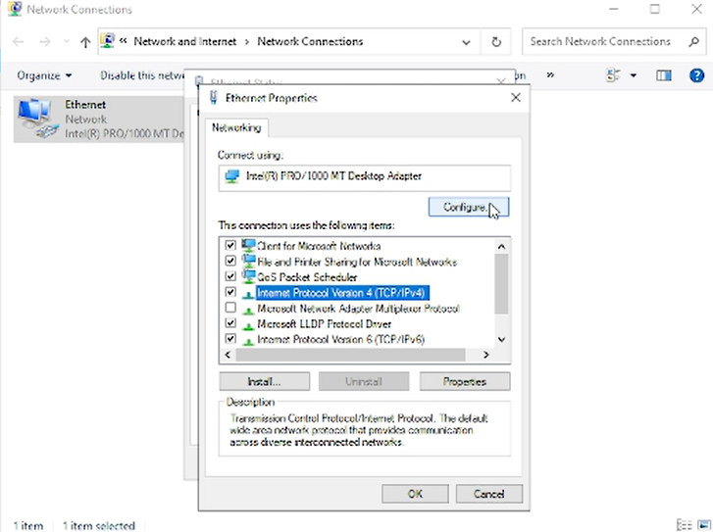 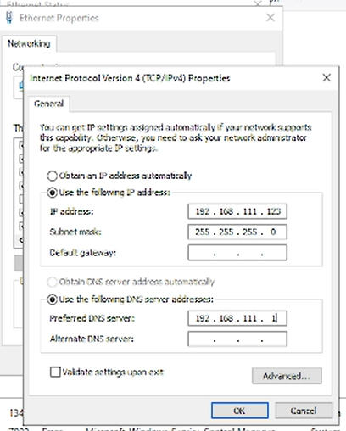

|  |
| --- |
| **CONFIGURATION** |

1. **CREATE DNS SERVER**

After completing the DNS installation, press "Promote this server to a domain controller" and select "Add new forest". Then, determine the domain name that you will use. In this project, we will use the name "sentosahospital.com" for the domain. After that, you will create a main password that you will use when logging in to the DNS server.

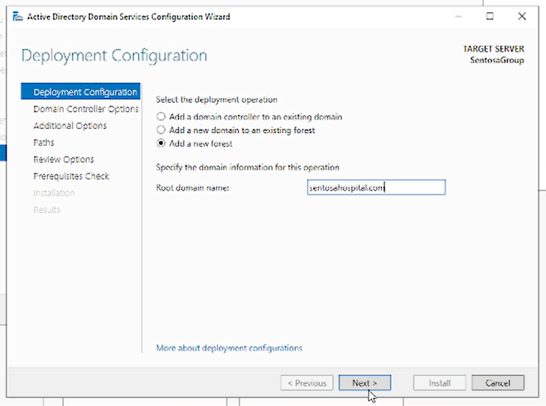 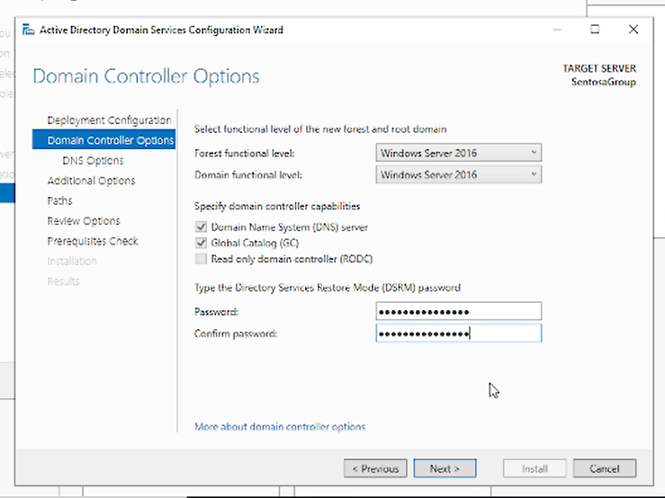

You can just click next in all the next point. After that, you can wait for the installation to complete. Once finished, your Windows will restart automatically. Then go to server manager. If successful, your domain will change to the DNS server you created earlier.

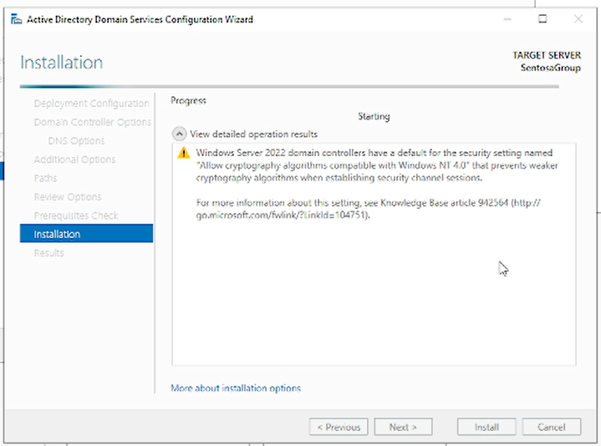 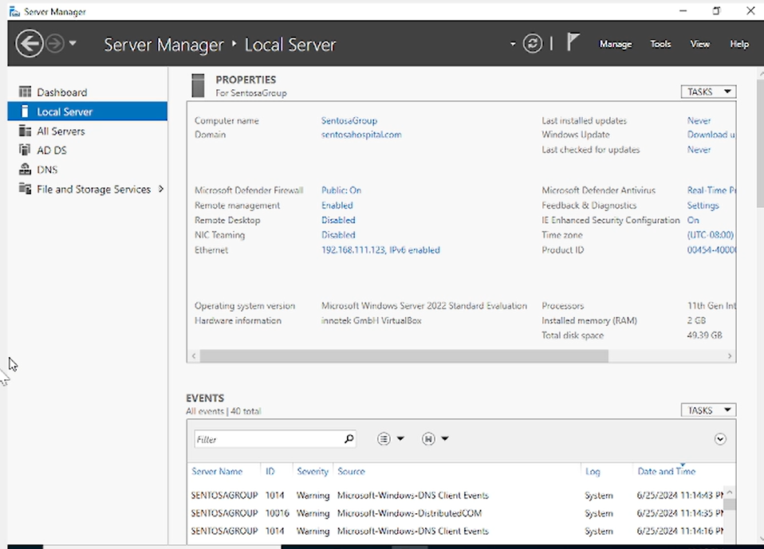

|  |
| --- |
| **CONFIGURATION** |

1. **CREATE ORGANIZATION UNIT & USERS**

To create an OU, you need to right-click your DNS section, then click "New" and select "Organization Unit". Enter the OU name you want then press "OK". Create OU is complete.

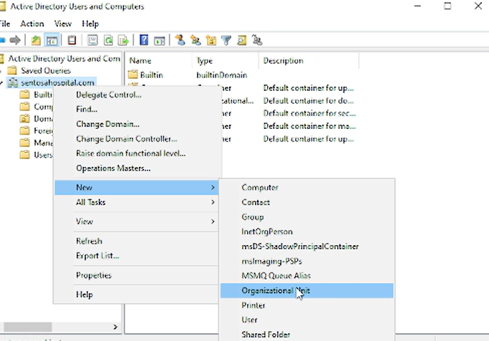 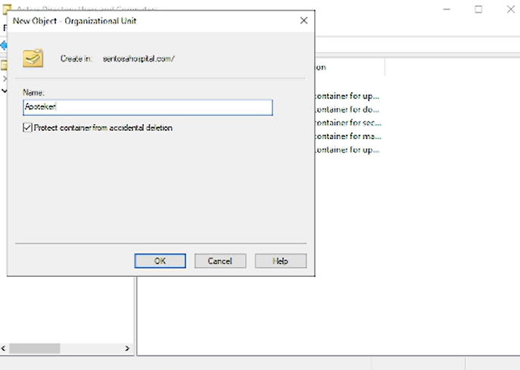

After creating an OU, you will create users in the OU. Right click on the selected OU page then click "New". After that, you click "Users". Then, you need to complete data such as name, logon name, & password for the user we will create. Create Users is complete. You can start logging in using the users you have created.

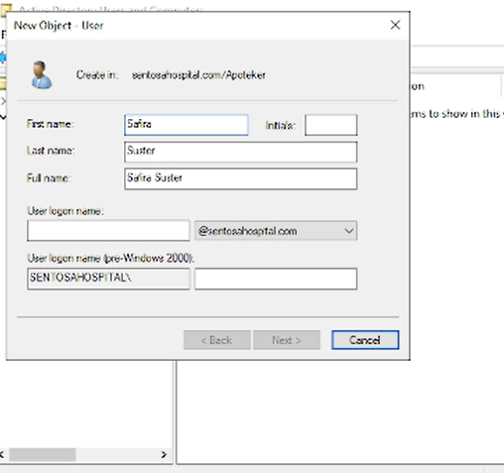 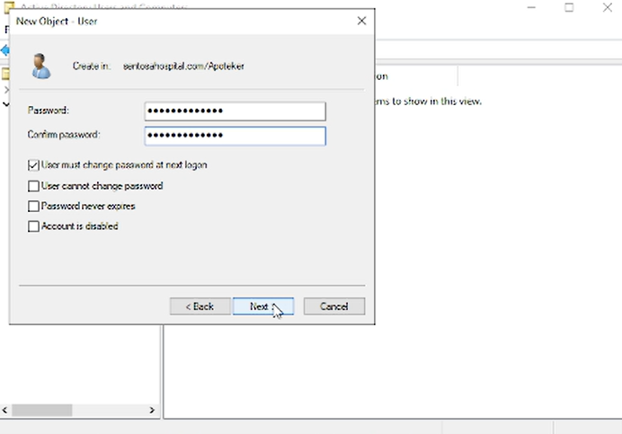

|  |
| --- |
| **CONFIGURATION** |

1. **CLIENT JOIN**

After creating DNS, OU, and Users, we need to connect them to the client computer. Before that, you need to install an operating system to be used as a client. In this project, we use Windows 7 as our client operating system. To connect, we need to change the IP address according to the DNS that we created on the server. After that, we need to change the domain name according to the DNS that we have created on the server. If successful, you will be asked to enter your username & password. Enter "Administrator" as the username and password according to the password you use on the client. If successful, your computer will restart automatically.

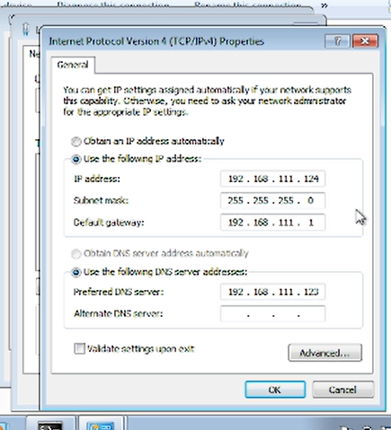 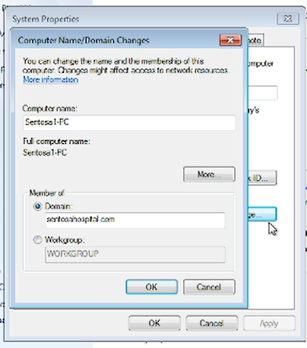

After the computer has finished restarting, you need to switch users. The user we will use is the user we previously created on the server. In this project, we enter the username in the format "sentosahospital.com\safirasuster". Then, when logging in for the first time we need to change the password for the next login and so on. After that, your client has successfully joined the server.

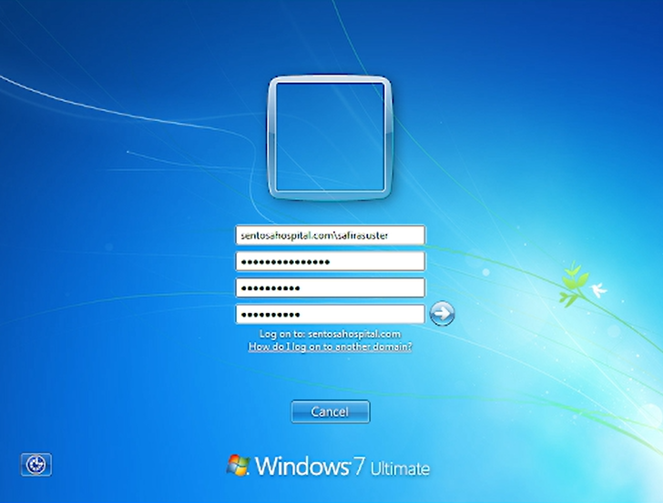 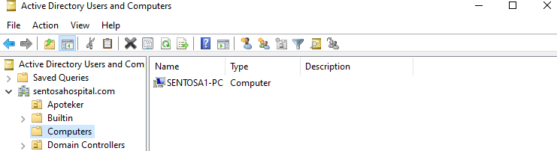

|  |
| --- |
| **CONFIGURATION** |

1. **MANAGEMENT FOLDER**

A To create a management folder, open the folder and create a new folder to configure. Right click on the folder and select “Properties”. Then, click "Share". On the next page, you will see several users who can execute the folder.

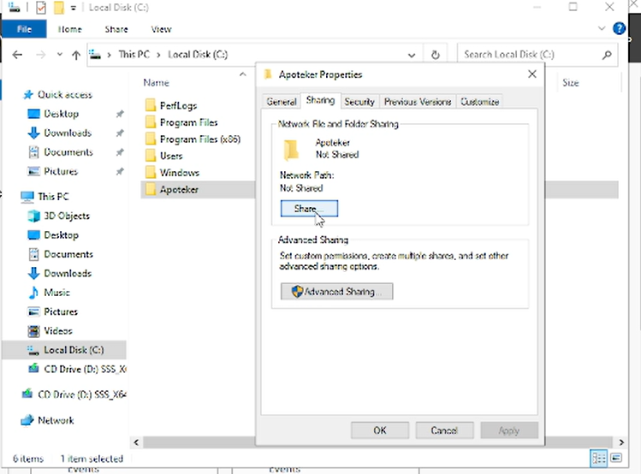 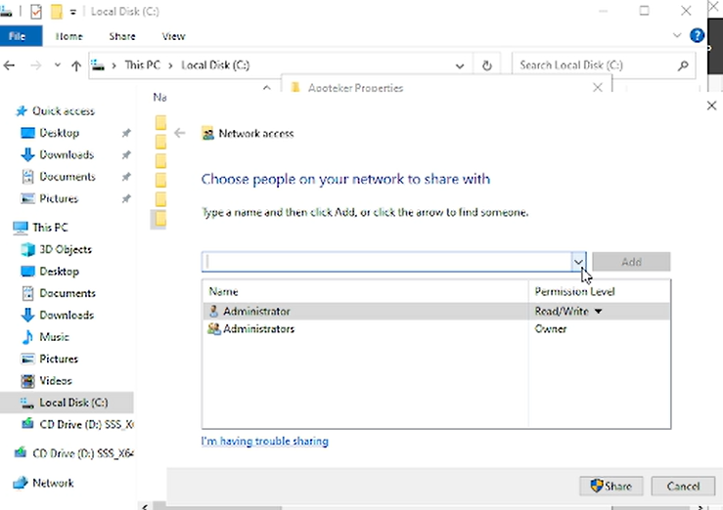

The purpose of this management folder is to set users who can execute a file. In this project, we want to add users to be able to execute the file. After adding the appropriate users in the OU, we can change the permission level of these users.

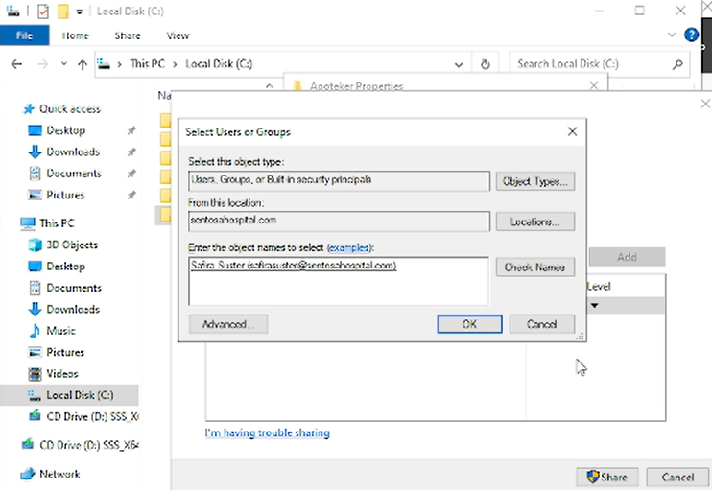 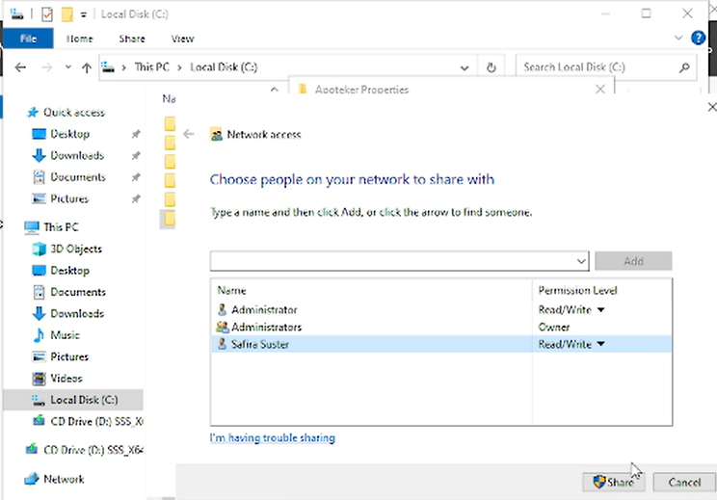

|  |
| --- |
| **CONFIGURATION** |

1. **GPO**

To create a GPO, you need the Group Policy Management tool. Open the tool, then in the DNS section, right click then press "Create a GPO on this domain..." then you need to create a name for the new GPO. Once finished, you can right-click the newly created rules section and click "Edit". There you can see various kinds of rules that you can activate

.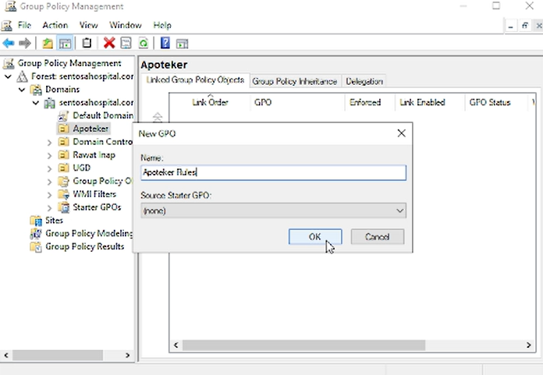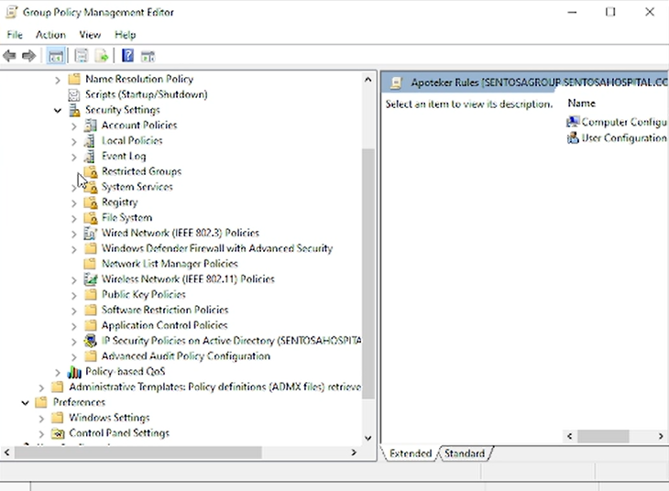

After that, you select the rules you want to use. Then, you can click on the rule and activate the rule then press apply. If you have selected rules, you can start “gpupdate” to activate the new rules.

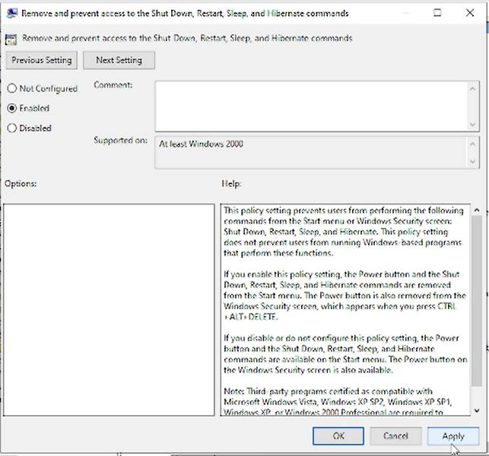 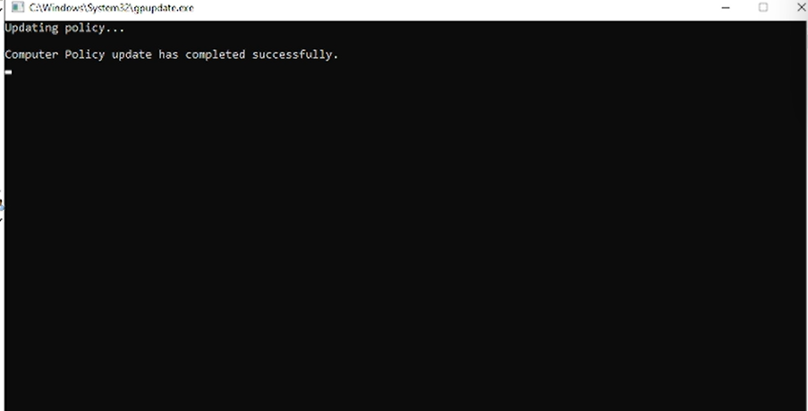

|  |
| --- |
| **CONFIGURATION** |

When you have finished activating a rule, you can check it on the client computer. In this project, we removed the power off, shutdown, & restart signs. Then, we also removed Pictures & music from the menu.

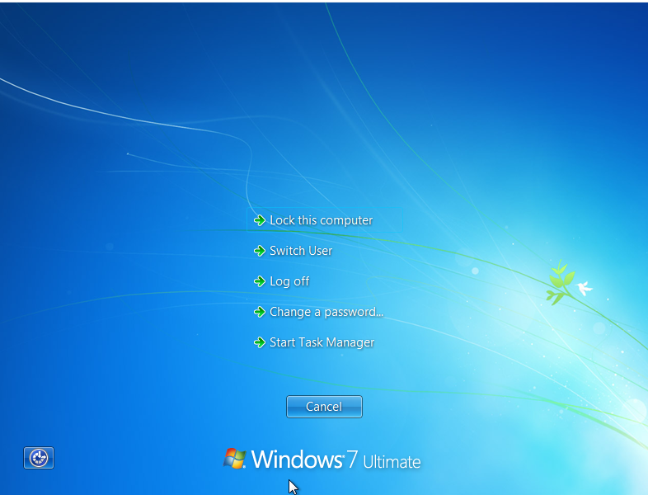 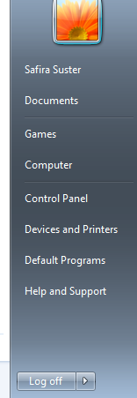

|  |
| --- |
| **CONFIGURATION** |

1. **WEB SERVER**

Install the IIS service on your server to create a web server. After the installation is complete, you can open IIS. In the Default Website section of Sites, you can press explore. Then, you need to edit the contents of your website page with HTML. If so, you need to save the html.

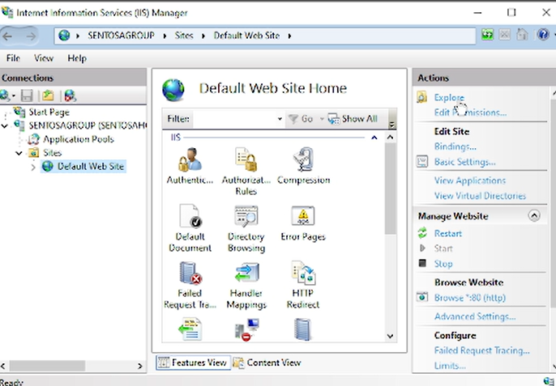 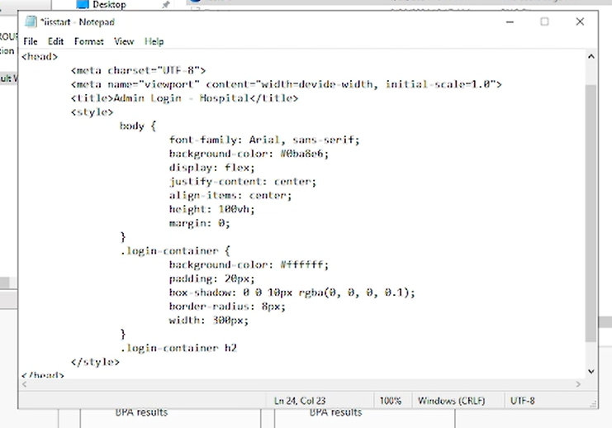

If the web server creation is successful, when you enter DNS into your client, the website you created previously will appear.

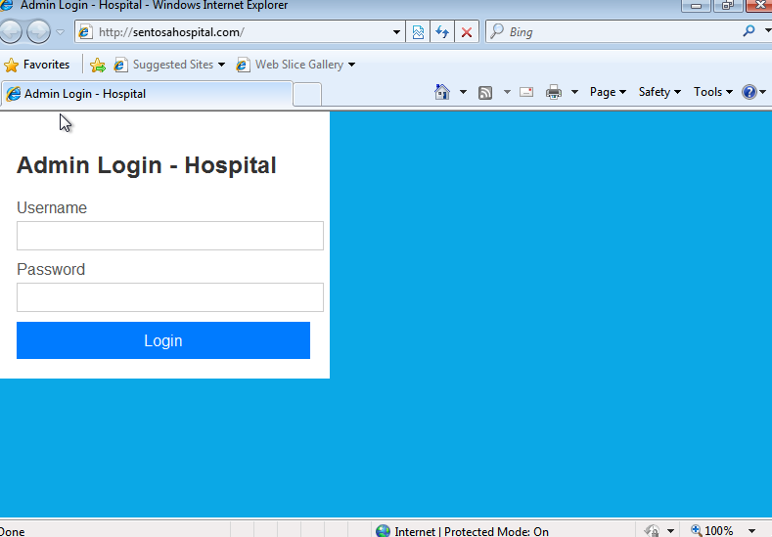

|  |
| --- |
| **REQUIREMENTS** |

|  |  |  |
| --- | --- | --- |
| **Hardware** :  1. Asus Laptop  **Operating System** :   1. Windows 11 64-bit 2. Windows 7 64-bit   **Software** :   1. Oracle Virtual Box 2. Ms. Word 3. Google Drive | | |
| **PROJECT FILE DETAILS** | | |
| No | Filename | Remarks |
| 1 | Grup 2 Project 3 FINAL.pdf | Paper File |
| 2 | Project 3 Presentation.pkt | Presentation File |